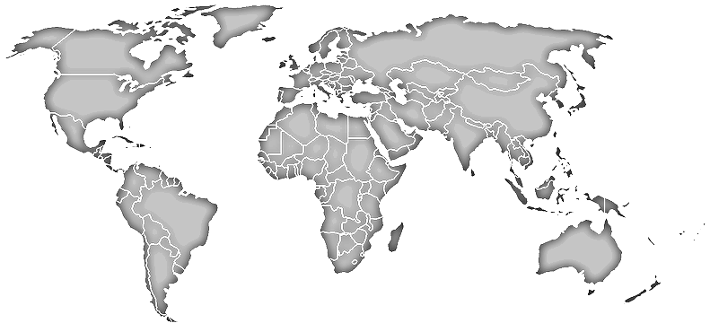

Biome World Tour Brochure
Group Names


Cover Panel:
___ Title present
___ Title catches attention of reader
___ Names of all participants listed
___ Clip art or photos add interest to brochure
Inside Panels:
___ All 6 biomes are present
___ Content is bulleted
___ Content is concisely presented
___ Critical characteristics are listed for each biome, including:
- Temperature (average and/or range)
- Annual Precipitation
- Other
___ Suggestions for travelers are included.
___ Suggestions for travelers are well thought our and specific to that biome.
___ Photos or graphics add value to the project. (Do not detract from content)
___ Font is easy to read in printed form

Outside Panel (left side)
___ There is a title for this panel
___ Information is present for:
- Reservations
- Dates
- ?
___ Contains sales pitch that would engage audience in learning more about earth’s biomes.
Back Panel (center):
___ Note empty
___ Content is relevant to the entire project.
FINAL CHECK
___ Group has checked entire project against checklist
___ Another group has checked project checklist
Comments:

___ Feedback was considered and changes were made or not made as appropriate.
___ Final copy printed
___ Final copy turned in to Moodle class.

